Middle Ages Acrostic Project
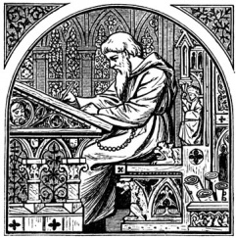
World History
Illumination is the decorating of books or manuscripts with ornate lettering, icons, and designs with luminous color and precious metals. During the Middle Ages, literacy was rare, so dedicated scribes created illumination to guide the viewer through the document. It was their artistic goal to provide comprehension, beauty, and honor to the pages they were writing because, in most instances, they believed they were copying the words of God. Thousands of examples have survived from Europe and the Middle East with stunning ornamental type and illustrative scenes.
Acrostic poetry is a form of short verse constructed so that the initial letters of each line taken consecutively form words. The term is derived from the Greek words, akros, “at the end,” and stichos, “line.” Medieval monks and poets also made this form of poetry popular during the Middle High German and Italian Renaissance periods.
Use the paper provided to make a MEDIEVAL acrostic. Your acrostic will be made from the word MEDIEVAL. Each letter should be illuminated and should have 5 stanzas (sentences) written in your own words (all five beginning with the illuminated letter). You must color each illuminated letter with at least 3 colors. This assignment will count as a project grade for this unit. You may use your notes and textbook for this project. All information on your acrostic needs to come from those two sources. Be careful not to plagiarize!
