The Islamic World
The Rise of Islam
- In the fifth century, warfare between the _________ and _________ Empires interrupted over land trade routes from East Asia. Trade in spices, Chinese silks, and Indian cottons shifted to the sea routes connecting India with Arabia and the Red Sea. Overland caravans carried goods up the western coast of the Arabian Peninsula. Cities and towns developed near _________ along these caravan routes.
- ______ was one of the most important of these cities. In the seventh century, a new religion emerged here: _______. “Islam” is Arabic for “submission.” Within a hundred years, Islam grew to control an area larger than ________________.
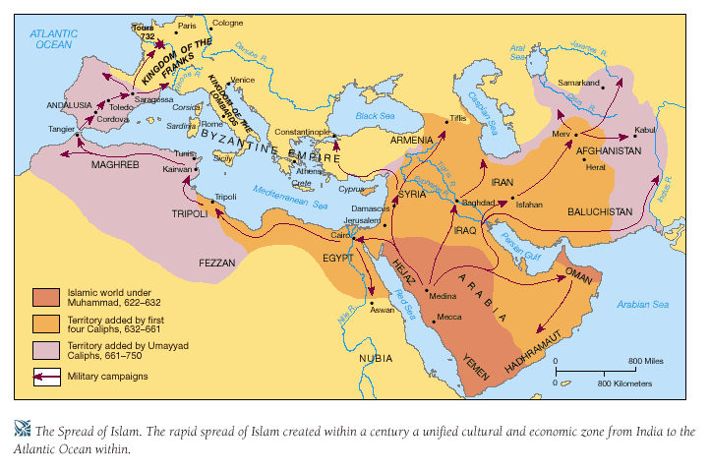
Mohammed: The Prophet of Islam
- Islam was founded by ____________. Born in 570, he worked in Mecca as a merchant and a shepherd. He had a religious nature and often meditated in a nearby ______. One day, Mohammed had a vision that the Angel Gabriel commanded him to convert the Arab tribes, who then believed in many gods, to belief in a single God, known in Arabic as “________.”
- This Allah was the same God worshipped by _____ and ___________. After his vision, Mohammed started to preach belief in Allah to his neighbors in Mecca.
- Some merchants in Mecca grew envious of Mohammed’s growing influence. Fearing for his life, Mohammed fled to the city of _______ in 622. This event, known as the _______, marks the _______ point of the Muslim calendar.
- In Medina, Mohammed became a popular religious leader. He gathered an army to retake Mecca in a _______, or “holy war.” In 632, two years after recapturing Mecca, Mohammed became ill and died. By the time of his death, most tribes of the Arabian Peninsula had united and converted to Islam.
The Quran (Koran)
- The Quran (Koran) is the ____________ of Islam. Muslims believe it records the words revealed to Mohammed by _________. Mohammed memorized these words and taught them to his followers. The scribes wrote these words down in the Quran. The Quran contains many references to both Jews and Christians. Its ____________also discuss forms of worship, proper conduct, and the treatment of ______, along with many other matters.
- The fundamental doctrine of the Quran is contained in two articles of belief: “There is no God but Allah; and Mohammed is his _________.”
The Five Pillars of Islam
- In contrast to some religions, Muslims worship God directly without the intercession of a priest or clergy. The Five Pillars of Islam – faith in one God (monotheism), prayer, charity, fasting, and pilgrimage – make up the basic _________________ that all Muslims must fulfill. In so doing, Muslims strengthen their faith in and service to Allah, whom they see as the supreme, all-powerful, all-knowing God.

- _____________________
Muslims must affirm: “There is no God but Allah, and Mohammed is his prophet.”
- __________
Muslims must pray _____ times a day, while facing the _____ towards the city of Mecca.
- __________
Muslims must give money to __________ and pay taxes to the Mosque.
- __________
During the month of Ramadan, Muslims cannot eat or drink during ___________ hours.
- _____________
If physically able, a Muslim must make a pilgrimage (religious trip) to _________.

The Islamic Religion Spreads
- Islam united the various Arab tribes with a common ______________ and religion. Strengthened by their newfound unity, they set out on a “___________” against non-believers. The Arabs were experienced fighters who fought with enthusiasm to gain entry into ___________.
- In contrast, by this time the Byzantines and Persians were both weakened from centuries of fighting with each other. Over the next century, Arab Muslims succeeded in creating a vast empire that extended from ________________ into Europe as far west as ______. Muslim expansion in Europe was only halted at the Battle of ______.
The Caliphates
- When Mohammad died, a group of Muslim leaders chose a new leader, whom they called a ________, or “successor to Mohammed.” Two of the early caliphs were ___________. A new caliph then founded the Umayyad Caliphate. Most Muslims, known as _______, followed the new caliph. A small group of _________ Muslims decided that only Mohammed’s descendants could be caliphs. The division between the Sunnis and Shiites remains to this day.
- Under the Umayyad caliphs, the capital of the Arab Empire was moved to ___________ (in present day Syria). After 750, a new family, the Abbasids, took over the caliphate. The Abbasids focused on trade rather than war, and built a new capital at ___________ (in present day Iraq). The Abbasid caliph governed as an absolute ruler and surrounded himself with a rich court.
- As Islam expanded, the caliphs converted or enslaved other peoples they found worshipping many gods. At first, non-Arab converts to Islam had ______ rights than Arabs, but eventually all Muslims were treated __________. Muslim rulers treated Jews and Christians with _________ since they were believed to worship ________________. They were permitted to have self-governing communities. However, Jews and Christians had to ____________________ and could not hold some public offices.
The Golden Age of Muslim Culture
- While learning was in ________ in Western Europe, a Golden age of Muslim Culture flourished – a period of great advances in __________ and __________. Arab Muslims absorbed the cultural achievements of the ________, Persians, _________, _______, and Byzantines.
- They also controlled a vast ________ area – larger than the ancient Roman Empire had been. The new Arab Empire, like the Byzantine Empire before it, served as a _________ for trade. Goods from India, China, Africa, Spain, and the eastern Mediterranean entered through Arab territories. This period also saw _______, the language of the Quran, achieve standardized use throughout the empire and become the language of literature, philosophy, and art.
- The prosperous ________ Empire attracted invaders from Central Asia. In the 11th century, Baghdad was captured by the Seljuk Turks – a Turkish tribe from Central Asia. Although __________, the Seljuk Turks converted to ________. Baghdad remained the capital of their new empire.
- In the 12th century, Muslims became engaged in a war with ________ over control of ___________, known as the Crusades. Christians captured Jerusalem in _____, but the city was later retaken by the Muslim leader and warrior, _________ (1137-1193). Until this day, he remains a hero to the Islamic world for uniting the Arabs and defeating the Crusaders in battle.
Arab Cultural Achievements
- ________________
Arab scholars borrowed the concept of zero from India and developed Arabic numerals, which were eventually adopted by other cultures. These developments led to great advances in algebra and geometry.
- ________________
Mohammed forbade making images of God or people. Islamic art is largely made up of geometric designs, flowers, and stars. Their textiles, leather works, and rugs are highly prized.

- ________________
Arab doctors discovered that blood moves to and from the heart. They learned to diagnose many diseases, including measles and smallpox.
- ________________
Muslim rulers built beautiful palaces and mosques, richly decorated with mosaics, calligraphy, and geometrical designs.

