Post-Classical Asia and Beyond
- In this chapter, you will learn about developments in Asia during the “post-classical” era of history, especially in _______, Central Asia, ______ and _______. You will also learn about later developments in parts of Asia, reaching into the next historical time period.
Rise of the ___________Empire
- In the last chapter, we saw how Arab Muslims created a vast Islamic civilization that eventually spread from Spain to the Indus River. The Ottomans, a nomadic group of __________ people originally from Central Asia, emerged as rulers of the Islamic world in the _______________.
- In 1453, they succeeded in capturing ______________, the capital of the Byzantine Empire. The Ottoman Empire was located between __________ and ________and interacted with both ___________ and ___________ culture throughout history.
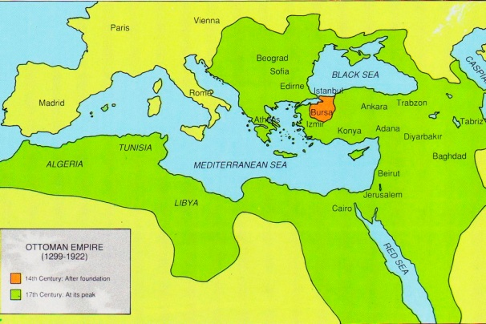
- For a time, the Ottomans cut ___________trade with ___________ and took control of the ________________. The Ottomans also conquered Egypt and North Africa, reuniting all of the ____________ world under their rule, except for ______-__ and _____________. They also conquered parts of Eastern Europe.
- By the mid-1500’s, under _____________________-, the Ottoman Empire reached its height. The Ottoman fleet controlled much of the __________ in the Mediterranean Sea until their defeat in 1571 by _____________ and _______________.
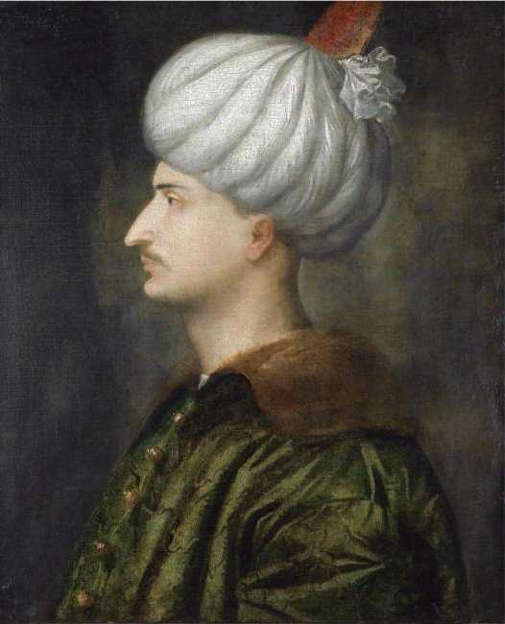
Sulaiman
the Magnificent
- At the heart of the Ottoman system was the ___________ (ruler) and his lavish court. The Sultan in Istanbul (Constantinople) governed the entire empire as an ________________ ruler. Under the Sultan’s rule, the early Ottoman Empire was well-organized and efficiently governed. He was assisted by a special army – the ________________, made up of soldiers recruited in _________________.
- The Ottomans recognized the __________________ of their empire. _________ and ______________communities were represented by their own leaders. These communities were governed by their own laws and collected their own taxes. These methods of government, as well as Ottoman control over the crossroads of trade, promoted ___________ and __________.
The Safavid Empire in Persia
- Islam also spread to __________. Safavids created a great Islamic empire in Persia in the early 1500s. Members of a _____________ tribe, the Safavids, were Shi’ite Muslims. They were opposed to the Ottomans, who followed the ___________ branch of Islam.
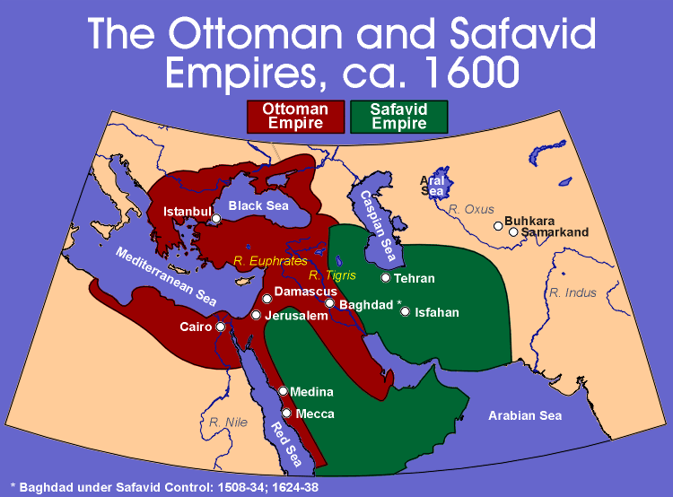
- Their association with Shi’ite Islam gave the Safavids and identity separate from their Turkish and Arab neighbors, still affecting ___________ today. Safavid rule eventually extended as far south as the _________________ and east to the Indus River. Safavid rulers, known as ___________, used their large standing armies to maintain control. The Safavid court became famous for its beautiful palace ___________ and ____________ in miniature.
The Muslim Invasion of ___________
- The impact of Islam was felt even farther east than ___________ and __________. As early as the 8th century, Muslim invaders reached the Indus Valley by entering across the mountains through the _________________ to the northwest of the Indian subcontinent.
- In the 11th and 12th centuries, Turkish Muslims invaded India’s northern plains, destroying ____________ __________ and cities. Historians believe large numbers of Hindus were tragically killed in these invasions. Muslims established independent kingdoms in Northern India, known as ________________.
- The most important Sultanate was established around 1200 in _______. For the next 320 years, the Sultans at Delhi ruled much of Northern and Central ________. Unlike prior conquerors, the Muslims never fully adopted Indian ways. For example, Muslim women wore __________ and remained _____________, even though ___________ women did not.
- At the end of the 14th century, the Mongol ruler, ________________ destroyed the city of ___________ and slaughtered its inhabitants. The Delhi Sultanate never fully recovered from this blow.
The ____________ Empire
(1526-1837)
- In 1526, Babur, a descendent of both Tamerlane and __________________________, defeated the Sultan of Delhi and founded the Mughal Empire. Although the name was taken from “______,” the Mughals were ____________ with close ties to Safavid Persia. Because the later Ottoman and Mughal Empires used__________ to control their populations and fight their enemies, historians often refer to these as the “________________Empires.”
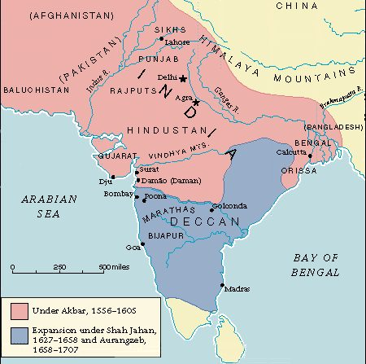
- The most famous Mughal ruler was Babur’s grandson, ___________________ (1542-1605), Akbar conquered neighboring Muslim and Hindu states, uniting ________________ under his rule.
- Akbar next set out to unite all his _________ and __________ subjects by promoting religious ______________. He ended the special taxes paid by the Hindus and made use of Hindu officials in government. To govern his large empire more efficiently, Akbar divided it into _____________provinces. Well-trained imperial officials were sent to supervise local government, enforce laws, and ensure the collection of __________. Akbar also encouraged _______________, painting, music, and literature.
- Akbar’s grandson, ____________________ (1628-1658), showed less sympathy for Hindus. He re-imposed special taxes on them and ordered the _______________ of many Hindu temples. In the northwest and northeast, many people converted to ____________. Some of these people changed their ____________ to avoid paying the special taxes. Others converted because they were from lower castes and hoped to escape the __________- system.
- Under Jahan’s rule, Mughal artistic and architectural achievements reached a _________ point. Jahan built palaces, fortresses and Mosques to glorify his reign. The most famous and beautiful of his buildings, the ________________, was a tomb built for his __________. It stands as one of the finest examples of Mughal architecture, merging elements of ___________, ___________, and _________ styles. Although the Mughals continued to rule in the north until 1857, a series of small, independent kingdoms developed in Central and Southern India. Soon afterwards, the Mughal Empire began to ________________.
Taj Mahal 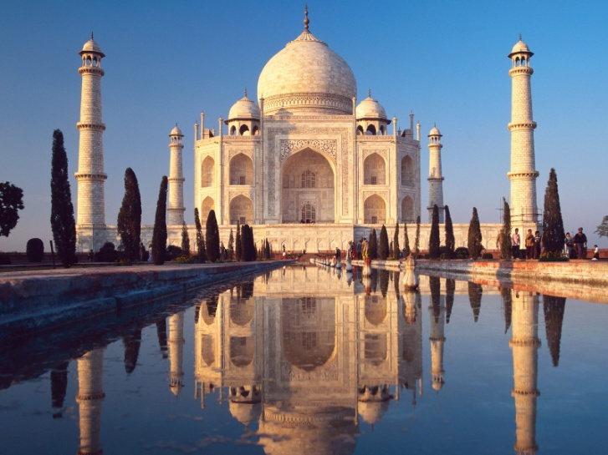
Sikhism
- Sikhism developed in Northern India as a result of the _____________- of Muslim and Hindu beliefs. Like Hindus, Sikhs believe in ___________________. Like Muslims, Sikhs believe in one God, and that God can be known through meditation (a form of deep contemplation). The goal of every Sikh is to build a close and loving relationship with God. Sikhs believe that everyone has equal __________ in the eyes of God. Sikh scriptures teach the idea of moderation, urging followers to ______ little, ________ little, ________ little, and to ___________ as little as possible. Unlike Hindus, Sikhs do not have castes. It is customary for Sikhs of all social ranks to take _______ together. Sikh men do not ___________________, which is often worn under a turban.
Sikhism – The Golden Temple 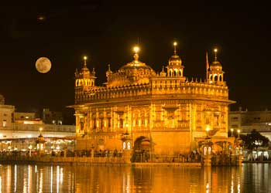
The Tang and Song Dynasties of China
- Like Western Europe after the decline of the Roman Empire, China entered a long period of ___________and unrest after the collapse of the Han Dynasty in 220 A.D. As in the West, the advance of the __________ helped plunge China into disunity. Several warring kingdoms arose, and science, art, and culture ____________. In these same years, ______________ spread through much of China.
- This period in China’s history is known as the _________________. It took several hundred years before China re-emerged as one of the world’s leading civilizations under the Tang Dynasty.
Tang Dynasty
(618-907)
- During the Tang Dynasty, China experienced a _____________. Early Tang rulers suppressed peasant uprisings, ____________ China, _________ traditional feudal relationships, and brought about peace and prosperity. They ruled over an immense empire of more than _____________ people. China expanded into __________, Manchuria, and parts of Central Asia. The government took careful __________ (population counts), gave examinations, and built public works. Under the early Tang, every adult __________ received a fixed amount of land from the government. Peasants had to perform labor for the imperial government and paid taxes in the form of ________ and ________.
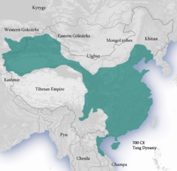
- Under Empress Wu Zetian, government officials made recommendations and reforms. A magnificent ______________ was built at Chang’an. At the time, this city was the largest city in the ____________. Merchants and officials from Persia, India, Arabia, and Syria could be found there.
- Architecture, sculpture, painting, and porcelain all made great advances. Stimulated by its contacts in the Middle East, the _________ Dynasty became one of the high points in Chinese civilization, especially with its accomplishments in _____________ and _______. Artists developed a distinct style of _____________ and with painted glazed figures of green, yellow, and orange. Artists also excelled in metalwork and jade. Vessels and utensils of all kinds were made by skilled craftsmen. Tang painters depicted nature with brushwork on scrolls, and Tang poets celebrated court life.
- Under the Tang, the Chinese developed a unique form of ____________ – with streams, rocks, and trees – designed for peaceful contemplation. The tang also made important innovations in map-making, medicine, and printing. Tang China developed block printing, so that copies of ________________ texts could be printed to help candidates for government service with their examinations. The Tang encouraged commerce and handicrafts, making the _______________ busier than ever before. Tang China benefitted from its trade with Persia, Arabia, Japan, and the Byzantine Empire.
Song Dynasty
(960-1279)
- After the fall of the Tang Dynasty in 907, China again __________ in size. In 960, the __________ Dynasty emerged in the south. Later, a rival dynasty was established in the north. Despite this reduction in area, _____________ China continued to build upon the achievements of the _________.
- The Song Dynasty was one of the most brilliant __________ eras in Chinese history. It was a time of great social and economic __________. China saw the first use of ________ currency, making it possible to pay taxes using money rather than _________. The government further minted strings of standardized _________, made of copper and iron. The Song also eliminated forced labor for the emperor. These factors helped bring about a large increase in farm production, which led to a greater ___________ for China’s people and government.
- Song China was the most ____________ and _____________ civilization of its day. Merchants, craftspeople, and scholars lived in the larger towns and cities. Bustling shops lined city streets. The Song capital housed more than _______________ people. China engaged in __________ with many other parts of the world.
- The __________________, connecting Beijing, the Hwang Ho, and the Yangtze River, was used to ship _________ within China. Caravans carried silks over the Silk Road. Large ships brought Chinese goods to Korea, Japan, Southeast Asia, India, and Africa. Science and technology also made advances. Song astronomers developed new instruments; doctors studied _______________; and mathematicians solved advanced equations. They introduced the use of ______________ in war, the compass in ______________, and invented movable type for printing.
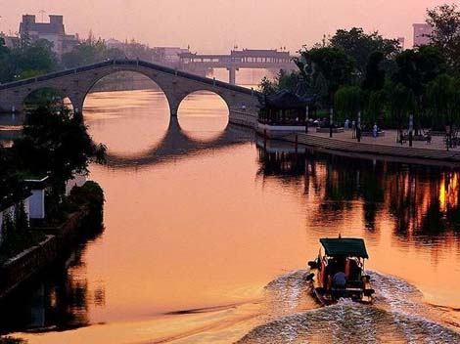China’s Grand Canal
- The greatest _____________ the Song faced consisted of tribes on China’s _________________ border. In order to secure their borders, the Song allied themselves with a new people in the north, the ____________. The alliance proved to be a ____________. The Mongols soon overran the empire and established a foreign dynasty to rule over China – the __________ Dynasty.
Women in China
- The Tang and Song followed the traditional beliefs of _______________ – a woman must obey her __________, __________, and ________. Girls left their families when they married. So long as they gave birth to sons, they would eventually gain a respected place in their new family by marriage. If a woman’s husband died, she could share in receiving a portion of her husband’s ____________. Divorce was allowed only if accepted by ___________ husband and wife.
- The practice of female ______________ began under the Song Dynasty and illustrated the desire to limit female ____________. Girls’ feet were bound in tight bandages. This gave wealthy women ____________ feet, which were considered attractive, but which often made it difficult for them to ____________.
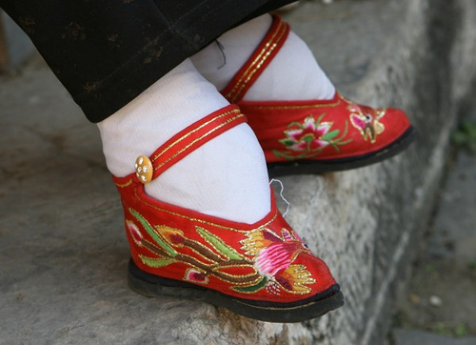
China’s Influence on Japan
- One area deeply influenced by Chinese culture was _____________. Chinese and Korean scholars and merchants brought many aspects of Chinese ______________ to Japan, a group of islands located close to Korea. Confucianism instilled loyalty to the ___________ and ruler. Buddhism taught the Japanese to renounce _______________, while Daoism encouraged the love of ______________.
- The Chinese method of _______________ characters was also adopted in Japan. Chinese music, art, and dance and even cooking influenced Japanese styles and tastes. The Japanese were greatly impressed by the quality of many Chinese goods, such as _________ and ___________. The ruler of Japan set up an imperial court, in imitation of China, and declared himself _______________.
- Although greatly influenced by China, Japanese society was not an exact copy. As time passed, Japanese emperors freed some of their nobles from their ________________. Many noble landowners began to raise their own private ______________ of warriors. The imperial government, collecting less taxes, grew _____________. Open warfare finally broke out between the leading noble families.
- In 1192, one of the nobles emerged as the most powerful. Instead of overthrowing the emperor, he had the emperor appoint him as Japan’s “_____________________________,” known in Japanese as the _____________. For the next 600 years, the Shoguns were the real rulers of Japan, with the emperors merely acting as figureheads.
- The Shogun stood at the top of Japan’s _________________. To provide military protection for their lands, noble landowners recruited ______________ warriors – knights on horseback with armor of leather and iron, and swords. Each samurai swore an oath of loyalty to the _____________ and to his local ___________ (noble). A samurai promised to follow a strict code of ____________ (bushido) that emphasized the loyalty of the samurai to the daimyo. In return for this loyalty, the daimyo provided the samurai with social status and ______________ support.
The Mongol Empire
- The Geographic Setting
Stretching across ________________ from the _______________ Mountains of Eastern Europe to ________________ in Northeast Asia is an almost unbroken band of treeless grasslands, known as the ______________. This band is situated between forests to the north and mountains and deserts to the south. From earliest times. Nomadic people have lived in this area by herding horses, sheep, camels, and goats. They have made use of the vast grasslands as pastures for their livestock.
- The steppes provided a unique environment in which these nomadic peoples developed excellence at __________________. And fierce fighting skills. Throughout history, a series of nomadic peoples have pushed out of this region to conquer their more civilized neighbors, sometimes with _____________ effects.
- The ___________, repelled by the Chinese emperors, invaded Europe and contributed to the collapse of the ____________ Empire. Later, the Turks and the Mongols also came out of Central Asia. The Mongols lived in the steppes of the _____________ part of Central Asia, ________________ of China. They slept in domed tents of felt, which could be easily moved. Like other Central Asian nomads, the Mongols were excellent horsemen and ____________. During the 1200s, the Mongols established the greatest empire the world had ever seen.
Chinggis Khan Unites the Mongols
- Like other ______________ peoples, the Mongols were divided into several loosely organized tribes. A Mongol leader named Chinggis Khan (or ____________ Khan) united the various Mongol tribes by 1206. After he had established himself as undisputed master of Mongolia, he set out on a career of conquest. Chinggis Khan next began _________________ neighboring peoples beyond Mongolia.
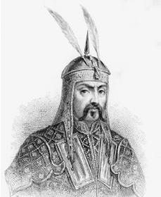
- Others had little chance against 200,000 skilled Mongol horsemen, riding with sturdy stirrups, carrying strong bamboo ________, and attacking cities with giant ___________. The Mongols became known for their fierce ______________, sometimes killing all the defenders of a city that refused to surrender without resistance.
- Chenggis Khan attacked Northern China, successfully taking the city of ___________. In 1219, he turned westward and captured the _________________ states of Central Asia.
- Although he was greatly feared as a brutal warrior, Chenggis Khan was tolerant of other ______________ within his conquered territories. He made use of __________ administrators and craftspeople. He promoted _________ throughout the vast Mongol Empire and even ordered the creation of a written script for the Mongol _______________.
- Under Chenggis Khans’ successors, Mongol rule extended into _________, _________, _________, and the rest of _________. The Mongols then held sway over one of the largest empires the world had ever seen -- from the _________ Sea to the ____________ Ocean. Under this “__________________,” people could safely trade from one end of the empire to the other. The Mongol Empire was so vast that it soon divided into four separate kingdoms, each ruled by a different __________________ of Chinggis Khan.
The Yuan Dynasty
- Chinggis’ grandson, __________________, was born a Mongolian, but developed a great fascination with _____________ culture, traditions, and art. He became emperor of Northern China in 1260. In 1279, he reunited Northern and Southern China under his rule. Mongols served as military ______________, ruling China with the help of Chinese officials. Kublai Khan encouraged the Mongols to adopt Chinese ways and even adopted the Chinese name Yuan for his dynasty. He claimed the ________________________________ in ruling China.
- __________________, a merchant from Venice, journeyed along the Silk Road and visited China in the 1270s. He was astounded at the magnificence of Kublai Khan’s court and the _______________________ superiority of the Chinese over the Europeans of his day. He was especially impressed by their use of gunpowder and their burning of ____________ as a source of heat.
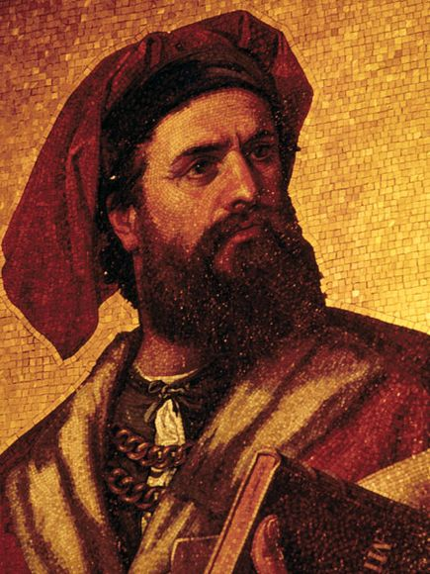
Mongol Influence on Russia
- In the 13th century, Mongol warriors also conquered most of Russia. They controlled it for the next ___________ years. Mongol words, customs, and even ____________ styles found their way into the Russian culture. Moscow and its surrounding territories, known as ______________, became the strongest Russian state. Muscovites eventually rebelled against the Mongols. In 1480, _____________________ declared Muscovy’s independence from the Mongols. He proclaimed himself __________ (“Caesar” or Emperor). Ivan soon set about increasing Muscovy’s size by conquering neighboring lands.
The Rule of _________________
- In the 14th century. Mongol power enjoyed a brief resurgence in Central Asia. Tamerlane, a Turkish-Mongol ruler, expanded his kingdom from Samarkand into Persia, Afghanistan, Russia, Syria, Turkey, and Northern India. Tamerlane was known for his _____________ in warfare and his _______________ of civilian populations. His empire did not long outlast his death.
The Ming Dynasty
(1368-1644)
- Despite their achievements, the Mongols remained _________________ in China. In 1368, the Mongols were overthrown by a Chinese ____________, who established the Ming Dynasty.
- Under the _____________ Dynasty, China enjoyed nearly 300 years of ___________ and __________________. Ming emperors expanded the empire to include __________, _________, and ____________. The Ming constructed an immense imperial palace in Beijing. Known as the ___________________, it became home to all later Chinese emperors, where they were revered as gods.
- Under the Ming, Chinese society consisted of __________ main classes. Most people were _____________, barely earning a living. The peasants were largely illiterate, and their lives centered around their relatives and the village. The other main social group consisted of the ____________________ class. They owned the land on which the peasants worked. The gentry greatly respected ______________. The Ming restored China’s civil service __________________, and children of the scholar-gentry studied to pass these demanding tests, which focused on _______________ teachings.
- In addition to these two classes, there were ________________ and _______________, who lived in the Ming cities. Craftsmen excelled at printing and in producing silks and porcelains of great beauty. Urban life and trade prospered, while China exported ________, porcelain and other ___________ goods.
- The Ming emperor sponsored several great _____________ expeditions in the early 1400s in order to spread the news of China’s ____________ and power. The Chinese explorer Zheng He sailed to the coasts of India and Arabia. However, in the 1430s, the Ming emperor suddenly ordered an _________ to those voyages because of the opposition of several noble families at court. Thus, just when Europe began _____________ its horizons, Chinese rulers halted their explorations, believing their system was already in ___________ __________ and that change would be harmful.
- Direct European contact with China was already _____________ in the 16th century. In 1557, Portuguese traders established a settlement on China’s _____________ coast. ____________ missionaries followed these merchants to China. They attempted to convert the Chinese to ________________. Ming China became involved in a pattern of global trade. China exported silk and porcelain to Europe and imported ___________ as well as new foods such as ___________ __________ and ____________.

