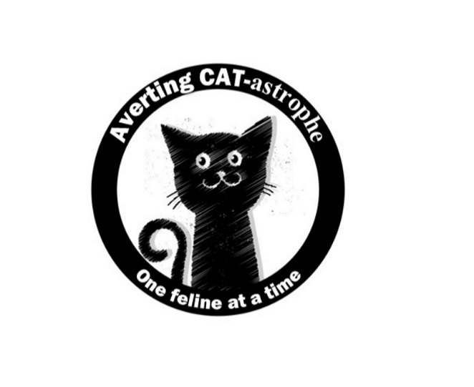
Averting CAT-astrophe, inc
One feline at a time….

Please email completed and signed application
to avertingcatastrophe@gmail.com

VOLUNTEER APPLICATION, AGREEMENT AND WAIVER FORM

Thank you for considering being a volunteer for Averting CAT-astrophe, inc!! We are a 501c3 non-profit cat rescue group consisting entirely of volunteers. Averting CAT-astrophe is committed to the rescue, rehabilitation, and placement of cats/kittens as well as public education regarding proper care and the importance of spay/neuter in battling the escalating overpopulation problem.

PLEASE READ AND FOLLOW CAREFULLY!!

- All volunteers must fill out this Volunteer Application form before conducting volunteer activities. You can submit this form many ways:
- Fill out the word version electronically and email it directly to us at avertingcatastrophe@gmail.com.
- Print out the word or pdf form, fill it out by hand, and send it to us via snail mail (Averting CAT-astrophe, P.O. Box 874, Mansfield, TX, 76063)
- Print out the word or pdf form, fill it out by hand, scan and email to avertingcatastrophe@gmail.com
- If you are over 14 years of age and under 18 years of age, a legal guardian must also sign the application, agreement, and waiver forms. An adult may be required to accompany minors during some volunteering activities. Proof of age may be requested.
- It is important to log all your hours and activities for our records, and submit them via email to avertingcatastrophe@gmail.com

Date: ___________________ Name: ________________________________________

Date of Birth: _______________ Street Address: _______________________________

City: ______________________ State: _______ Zip: __________________________

Email Address: ___________________________________________________________

Cell Phone: _____________________________ Home Phone: _____________________

Work Phone: _____________________ Best way to contact you: ___________________

Is this for Student Service or other credit / required service? _______________________

How did you hear about us? _________________________________________________

Please list a contact in case of an emergency. If you are under 18, the person must be a parent or guardian:

Name: ______________________________________ Relationship: ________________

Cell Phone: __________________________Home Phone: ________________________

Work Phone: _________________________

Do you know any other Averting CAT-astrophe volunteers? If Yes, please state names and relationship: ________________________________________________________________________________________________________________________________________________________________________________________________________________________

Do you currently volunteer for any other animal welfare organization? If yes, how do you participate? ________________________________________________________________________________________________________________________________________________________________________________________________________________________

Have you ever adopted an animal from Averting CAT-astrophe? ___________________

Please put a check by all areas of volunteering that you would like to assist with:

- Adoption Events _____
- Fundraising Coordinating _____
- Grant Writing _____
- Admin _____
- Gathering / Creating Donation Items _____
- Transporting _____
- Volunteer Coordinating _____
- Other: _______________________________________________________

When becoming a volunteer of Averting CAT-astrophe, you will be required to abide by this Volunteer Agreement and Waiver form. Please read it and fill it out carefully.

During all volunteer activities of Averting CAT-astrophe, I ________________________ understand that I am expected to abide by the following statements, and that by signing this agreement and waiver form, I acknowledge that I have read and understood this form.

- I will treat all animals and other volunteers with respect, and I will work as a team member with all volunteers. I understand that the rescue of animals is Averting CAT-astrophe’s mission and highest goal and that all activities must be done collaboratively and with consideration of others for this mission to be accomplished.
- I am aware that as a volunteer of Averting CAT-astrophe, I am acting as a representative of the organization and agree to act responsible at all times by maintaining a professional demeanor. I understand that it is important to protect the reputation of Averting CAT-astrophe at all times, and the even though sometimes people can be grumpy and rude, I will always do my best to be understanding, helpful, and use good customer service.
- I will take all complaints to the volunteer in charge and not to any other member of the public. (We will get the problem worked out without any hesitation.)
- I agree to follow through with any responsibility that I have committed to and to arrive on time to any event or activity I have agreed to assist with. If for some reason I am unable to attend an activity I have said I will be at, or if I am going to be late, I promise to make every effort to contact the volunteer in charge.
- I agree that any animal rescued by Averting CAT-astrophe is owned solely by and is property of Averting CAT-astrophe, and as a volunteer of this organization, I will not withhold, sell, or give away any animal entrusted to me by the organization. I will follow all rules regarding animal release and adoption, and will not break them for any reason.
- I understand that I may not be reimbursed for any expense that I incur while volunteering for Averting CAT-astrophe unless it has been pre-approved by the Averting CAT-astrophe Board of Directors.
- I hereby grant and convey unto Averting CAT-astrophe all right, title, and interest in any and all photographs, images, and video or audio recordings made by Averting CAT-astrophe during volunteer activities for use in media, website, promotions, social networking, etc.
- I understand the possibility of risk of transferring disease-causing microorganisms during animal handling activities from Averting CAT-astrophe animals to myself and to my personal animals or vice versa. I agree to take all precautions to avoid such transfer, and I agree to the importance of having myself and my pets up to date on all current vaccinations, and that I should be in particular up to date on my tetanus vaccination and covered by a health insurance plan. I understand that Averting CAT-astrophe will not be responsible to pay for any vaccination, for my pet or myself.
- I understand that although Averting CAT-astrophe will make every attempt to ensure the safety of their volunteers and animals, rescue animals are by nature unpredictable in their behavior. Therefore, I assume the risks of being bitten, scratched, injured, or frightened by cats, kittens, dogs, and puppies in connection with my volunteer work for Averting CAT-astrophe Neither Averting CAT-astrophe or any of its Directors, volunteers, fosters, or other affiliates are liable to me for any injuries, damages, liabilities, losses, judgments, costs, damage to property or expenses whatsoever that I might suffer or sustain in connection with the performance of my volunteer activities for Averting CAT-astrophe . I will indemnify, defend, and hold the Averting CAT-astrophe Directors, volunteers, fosters, or other affiliates harmless from and against any claims, lawsuits, injuries, damages, losses, costs, or expenses whatsoever sustained by any foster animal or any person in connection with my intentional misconduct or grossly negligent performance of volunteer activities for the Averting CAT-astrophe or my breach of the Averting CAT-astrophe’s rules, regulations, policies, and programs.
- I understand the potential safety risks of working with animals and that I may not bring friends or family members with me while volunteering for Averting CAT-astrophe, unless they have also submitted a Volunteer Application, Agreement, and Waiver of Liability, or prior arrangements have been made in advance with the Averting CAT-astrophe’s Directors. I also understand that if I chose to bring a minor that I am a legal guardian of, while volunteering, that I am responsible for that minor and will take all precautions necessary for the protection of them and Averting CAT-astrophe animals. If I am 14 – 18 years of age you must be accompanied by an adult at volunteer events that require it.
- I authorize Averting CAT-astrophe volunteers to seek emergency medical treatment for me in case of accident, injury or illness.
- I understand that if I fail to abide by the terms of this Agreement & Waiver form, or am otherwise unable to meet the requirements of the volunteer program, which are subject to change by Averting CAT-astrophe Directors at any time, I understand that I can be terminated from the program. I also understand that I may, at any time, be removed from my position as a volunteer at the discretion of the Averting CAT-astrophe Board of Directors. However, as we are an all-volunteer organization, we really need you and like having you around. If you are nice to the animals all the time and to us and all the other volunteers most of the time, you will be appreciated. We love our volunteers and can’t do this without them!
- All information that I have supplied to Averting CAT-astrophe in my application and agreement, or elsewhere is accurate and truthful to the best of my knowledge.

Signature of Applicant: ___________________________________ Date: _________
Please print/type first and last name: _________________________________________
Signature of parent or guardian: ______________________________ Date: __________
*Volunteers 18 years of age or under must have parental approval.

