World History Extra Credit Project
Name_________________________________________
Date__________________________________________
Period________
African Kingdoms Mask Project
Objective: Students will understand that because the people of West Africa did not have a written language, their culture has been passed down through oral history, writings by other people, and the arts.
Directions: Read the following articles, then complete the Project Task page.

West African Tribal Masks - What is the Purpose of Their Existence?

Africa is not short of Art and culture, there are many beautiful art pieces that Africa has given the world, but today you will learn about African Masks. West African masks in particular, as well as looking visually striking have many layers of meaning and hold symbolic importance in the tribes they come from. Some that you will uncover as you read on further...

African masks are traditionally worn by tribes who use it for many different things. There are different purposes for the creation of each mask and it is dependent on the region of Africa they are made and from what tribe they came from. One of the stand out indicators of a masks purpose is the facial attributes it has. An example being in some tribe's a long, stretched face symbolizes the soberness that power brings.

Masks have been known to be used and specifically made for spiritual ceremonies in which the spirits of ancestors are conjured through special dance and song, by wearing the mask. These souls the tribes believe will watch over them through their lives, shield them from evil spirits and in some cases help them to win a war at hand.

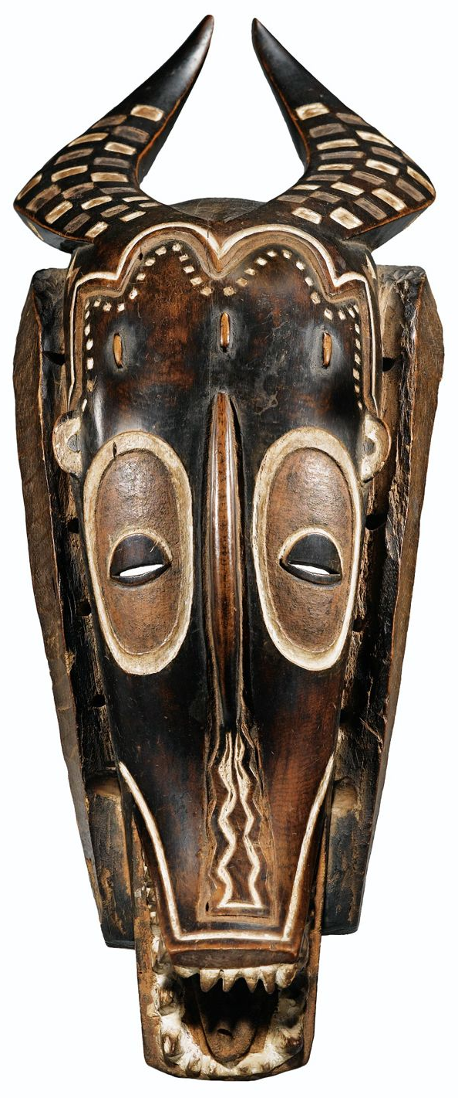
Tribal masks are made by specially trained individuals who have been taught by an elder in the community with years of experience in the craft of mask making. A master or expert carver is a job that comes with much prestige, in order for one to take on this role they would need to understand meanings of color and spiritual markings.

Masks are made from differing materials and the material used is often an indicator of how important the mask is. The materials used in making the masks range from wood, metal, ivory and stone. Some tribes have been known to file down animal bones and use it for extensions on masks.

Masks can also represent the cultures ideal of feminine beauty. The Punu of Gabon has masks that epitomizes female beauty in their culture and is only worn by men on stilts. The masks have almond shaped eyes, a narrow chin and dark black hair style which tops it off. The face of the mask is white and represents the beauty of the spirit world. The Idia's mask of Benin is a famous mask among African art lovers which was made in memory of the king of Benin's mother. In honor of his mother he wore it by his side near his hip during special ceremonies.

Many masks from Africa are made for a concept or a few, rather than to represent an individual. A mask may be made to represent "wisdom of a man" for example and will feature standout facial characteristics to further add to its cause. West African masks are an amazing part of African culture as they are visual representations of the beliefs of a tribe and also an object of historical insight. A West African mask has meaning and a depth that one can only contemplate when they understand the reason for existence.
Article Source: http://EzineArticles.com/4426613

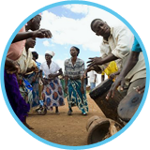
THE GRIOTS OF WEST AFRICA – MUCH MORE THAN STORY-TELLERS

As the bride and groom leave the town hall in Bingerville, just west of Abidjan, a group of women sing and dance. The lead singer cups her hands around a small megaphone to project her voice. They sing the praises of the just-married woman, and gather around the more affluent members of the wedding party, praising their nobility and beauty – all with a twinkle in their eyes and an expectation of reward.

Origins
The griot tradition has proved remarkably resilient in West Africa, seven centuries after its beginnings during the Malinke Empire which stretched from modern day Senegal to Timbuktu and Gao in Mali and even included parts of Côte d’Ivoire. The griots were advisors to court, story-tellers, musicians and praise-singers drawn from five leading griot families.
At a roadside café in Williamsville, Abidjan-based griot Bakary Koita greets me with a broad smile. As I ask my first question, he recites a prayer in Arabic, praying for our conversation to be successful. “The word griot means lots of different things”, he tells me. “First of all, a griot’s first job is to be serious. In all that you do, you need to be professional. When there are family problems in your neighborhood, it’s the griot that intervenes. When there are arguments, the society calls on a griot, so a griot has a big role to play. He shouldn’t be false, he should have a good behavior, he’s a guide – others look to see how he lives and how his family live. That’s a start on what griots are – they’re do-gooders.” Bakary is the treasurer of the Association de Griots d’Abidjan (English: Association of the Griots of Abidjan). “You can’t make yourself become a griot. You’re born that way. Being a griot is an art. You’re born with it, and you need to exercise it at any moment,” says Bakary, who is a hereditary griot on both his father’s and his mother’s side.

The social tasks of a griot
Traditionally, griots were a social caste, dedicated to preserving the memory of society. “Without us, the names of kings would be forgotten, we are the memory of humankind. By the spoken word, we give life to the facts and actions of kings in front of the young generation”, said griot Mamadou Kouyaté, quoted in Djibril Tamsir Niane’s Soundjata ou l'épopée mandingue (English: Soundjata or the Mandinka epos). The exact role of a griot is multi-faceted, but in general, the work is a service, particularly to the richer members of the community and for those who (at least in the traditional sense) are considered to be nobility. While griots can be called upon to work at any moment, their specialty is formal ceremonies. “When there’s a marriage, it’s for us. When there’s a baptism, it’s us. When there’s a funeral, it’s us,” says Bakary.
The griot expects a reward for his services as part of a patronage system of wealthy lords, though some griots may also practice a separate trade on the side, such as leather work. A griot does not belong to one person; he belongs to all of society. Bakary explains his position: “I’m a griot – I don’t have things to sell or set up a stand at the market! But I need to feed myself, pay my rent – where does this come from? It comes from the nobles. I’m in the service of the noble. Through him, I can serve all the community.”

The griot in modern times
While the spoken word remains the key tool of a griot, he also retains a close bond with music. There are both male and female griots, though the latter tend to specialize in singing and generally do not play more than simple percussion instruments. The four principal instruments are the kora, the balafon, the ngoni (lute) and the voice. Accordingly, some of West Africa’s high profile musical stars are also tied to the griot. Artists such as Guinea’s Mory Kanté and Senegal’s Mansour Seck come from traditional griot castes, and the Senegalese singer Youssou N’Dour has a maternal connection to the griot caste. But in a break with tradition, others – most notably Salif Keita – have adopted a cultural role which in a traditional society wouldn’t have been theirs to fill.
Beyond music, the concept of the griot has proved flexible and attractive. A whole variety of artists have found meaning in the title which helps them tap into centuries of authentic tradition. The Senegalese film director, Djibril Diop Mambéty, whose most famous work Touki Bouki(1973) is considered one of Africa’s best films, said that “the word griot (...) is the word for what I do and the role that the filmmaker has in society... the griot is a messenger of one’s time, a visionary and the creator of the future.”
Griots frequently compare their work to an ancient baobab tree or a library – a living, speaking testimony to a society’s history. “We can say that they are the memory of the Mandingue people”, says Professor Dagri. “There’s a Mandingue proverb that says “May God move so that griots never perish in war, on the battle field, but every battle field needs a griot, for without his presence the history of what happened would be forever lost.”
John James, Côte d’Ivoire, 2012

Visit us at Goethe-Institut Johannesburg
Think About It:
Music, art, clothing, dance, and other cultural traditions have survived and flourished from the great West African kingdoms of the past. Modern blues musicians were influenced by African music, artists such as Matisse and Picasso were inspired by African art, and today, African proverbs are used as inspiration for many!

If your only tool is a hammer, you will see every problem as a nail. — Gambian proverb

Project Task:
Based on the articles you have read, your class work, and your own research, you will now create a one of a kind African mask! It is up to you to create a West African styled mask. Use your creativity to find materials to construct and decorate your mask. Feel free to look up some masks online for inspiration. Remember, masks were used to honor ancestors or animals, so make sure that your mask is accurate. Be careful with your mask, making sure it is in good condition when you turn it in. No computer generated images will be accepted. Do not use items that you would be concerned with damage or loss.
Be creative…! Construction paper, wrapping paper with appropriate color and design, raffia, straw, grass, cloth, seeds, clay, or other materials are just a few of your possibilities!
You will also be responsible for finding a West African proverb and writing it at the top of the write-up page.
“AS 6-YEAR-OLDS in Zimbabwe, we were taught proverbs before we were taught how to navigate the nuts and bolts of Shona (the most common language in the country). This approach left some students capable of dropping rich wisdom freely but not being able to ask you how your day was.
Many African proverbs are strongly tied to the earth and animals, conveying lessons of life and learning often through daily, seemingly menial, procedures. An example of a Zimbabwean proverb is “there is honey but no bees” — describing a situation when you find something free for the taking and without consequence.”
(http://matadornetwork.com/bnt/50-african-proverbs-to-get-you-thinking/)

Your job is to look up and find an African, preferably, West African, proverb. Please identify the country or civilization that the proverb originated from within your write-up.

After your mask is completed, please proceed to the Project Write Up.

Project Write Up:
Based on the articles you have read, the class work you’ve completed, and your own research, please answer following questions:

1. What is represented on your mask (animal, warrior, etc…), and why did you choose to make a mask of it?

2. Why were the arts, music, clothing, sculpture, masks, etc…, important to the people of West Africa?

3. What information struck you as interesting during your research? Describe something that interested you and any questions you might have thought about that would like to have answered.
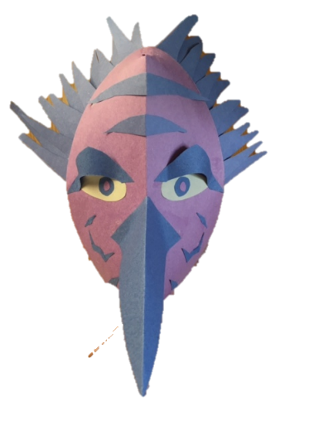
Your completed write up should be a minimum of 1 typed page long. Use default, 1” margins, and 12pt font. Be clear and thorough in your responses. Be sure to write neatly and in complete sentences. You may use any educational, legitimate source, but you must site ANY sources used on the back of the write-up page. You MUST have cited sources to explain your use of designs in your mask. Failure to cite evidence will result in a significant loss of possible points.

Your completed Extra Credit Project (with write up) is due _____________________.

