French Revolution Poster Project
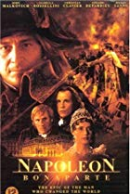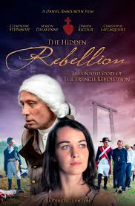
You will design a movie poster based on a person or event that occurred during the French Revolution. The size of the poster will be 11 x 17 (or paper supplied). Artistic ability will not necessarily affect your grade, but lack of effort will affect it greatly.
Requirements
1. Movie Title - Turn the event into a movie, give it an interesting name. Do not use the name of
the event. Ex: Do not title the Reign of Terror the “Reign of Terror”.
2. Artistic representation of the historical figure, event of topic - Draw an interesting
representation of the figure or event. You are trying to draw interest into the event so people will
watch your movie.
3. One-liner/Slogan - Movie posters always have some sort of one line slogan that is meant to
intrigue the audience into attending the movie. Is the slogan a question, a quote, or a joke? You
decide.
4. Star or Director -Show the important historical figures and their influence on the event.
Ex: George Washington was the actor in the American Revolution and the Founding Fathers were the
Directors.
5. Movie Summary/Synopsis - Summarize the event depicted on your poster as though you
were writing a summary/overview of the movie to be placed on the back of the poster. Length should
be ¾ to one page.
6. Neatness - Your poster should be well organized and easy to see from a distance. Avoid
unnecessary blank space, but also avoid overcrowding the poster.

Topic - Choose from the topics below.

1. The Third Estate
2. The Storming of the Bastille
3. July 14, 1789
4. National Assembly & the Tennis Court Oath
5. Jacobins
6. Georges Danton
7. Murat and his death in the tub
8. Robespierre
9. King Louis XVI & Marie Antoinette
10. Guillotine
11. Reign of Terror
12. Temple (Cult) of Reason
13. Liberty, Equality, Fraternity
14. Napoleon Bonaparte
15. Napoleon in Russia
16. Battle of Waterloo

If you think of another topic/idea it must be approved first.

